**ResNet18 + MLP Classifier Model Performance Report**

Kanishak Sharma BT22GCS202 R&D Project

### **Training Images**

* **Class 0 (Potato Early Blight)**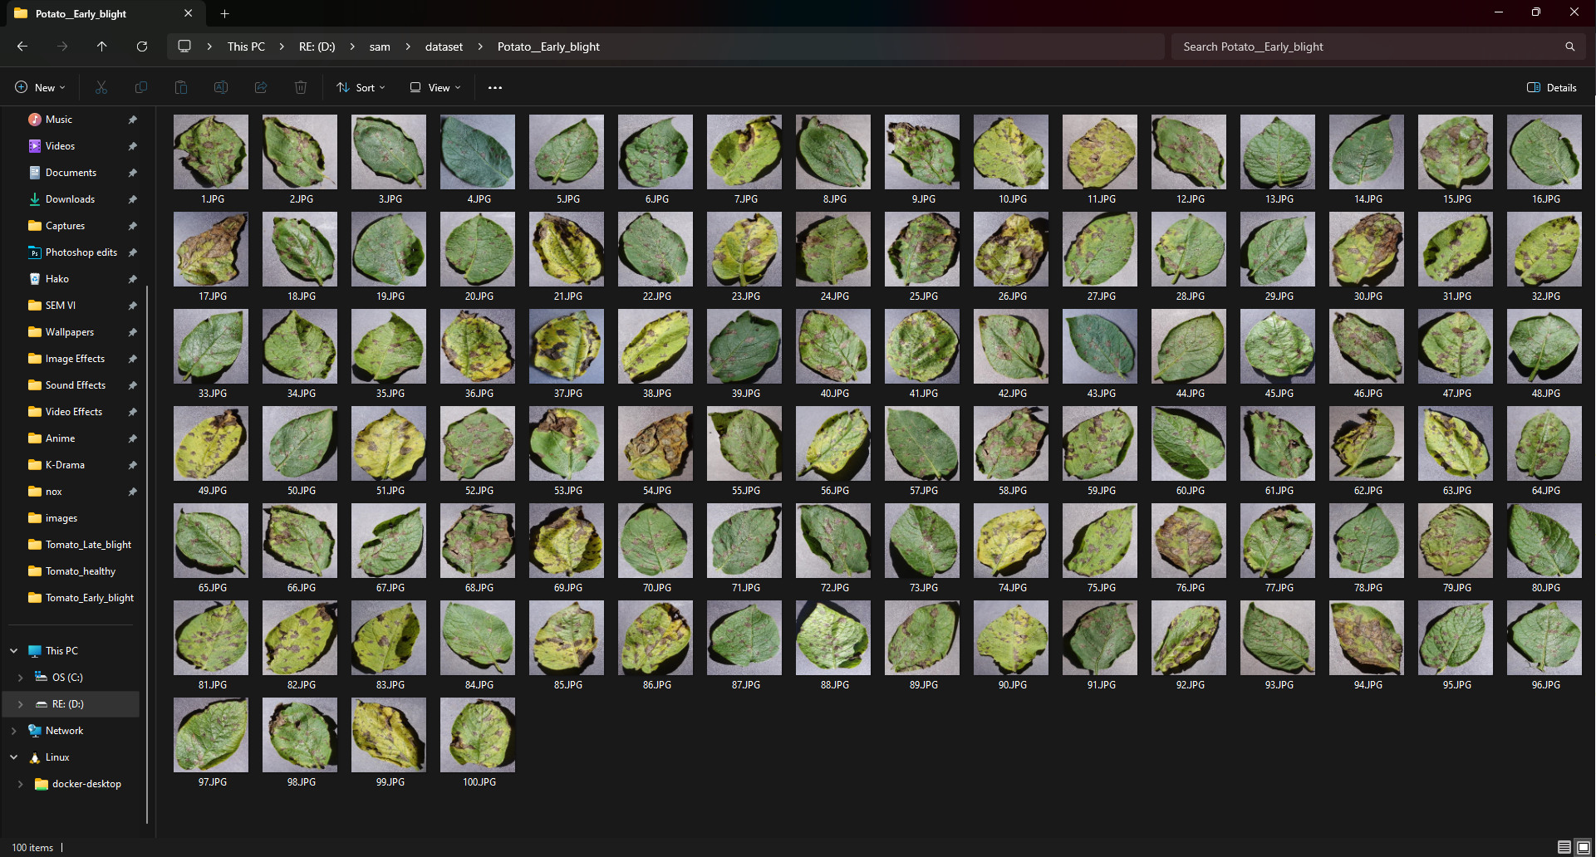
* **Class 1 (Potato Healthy)**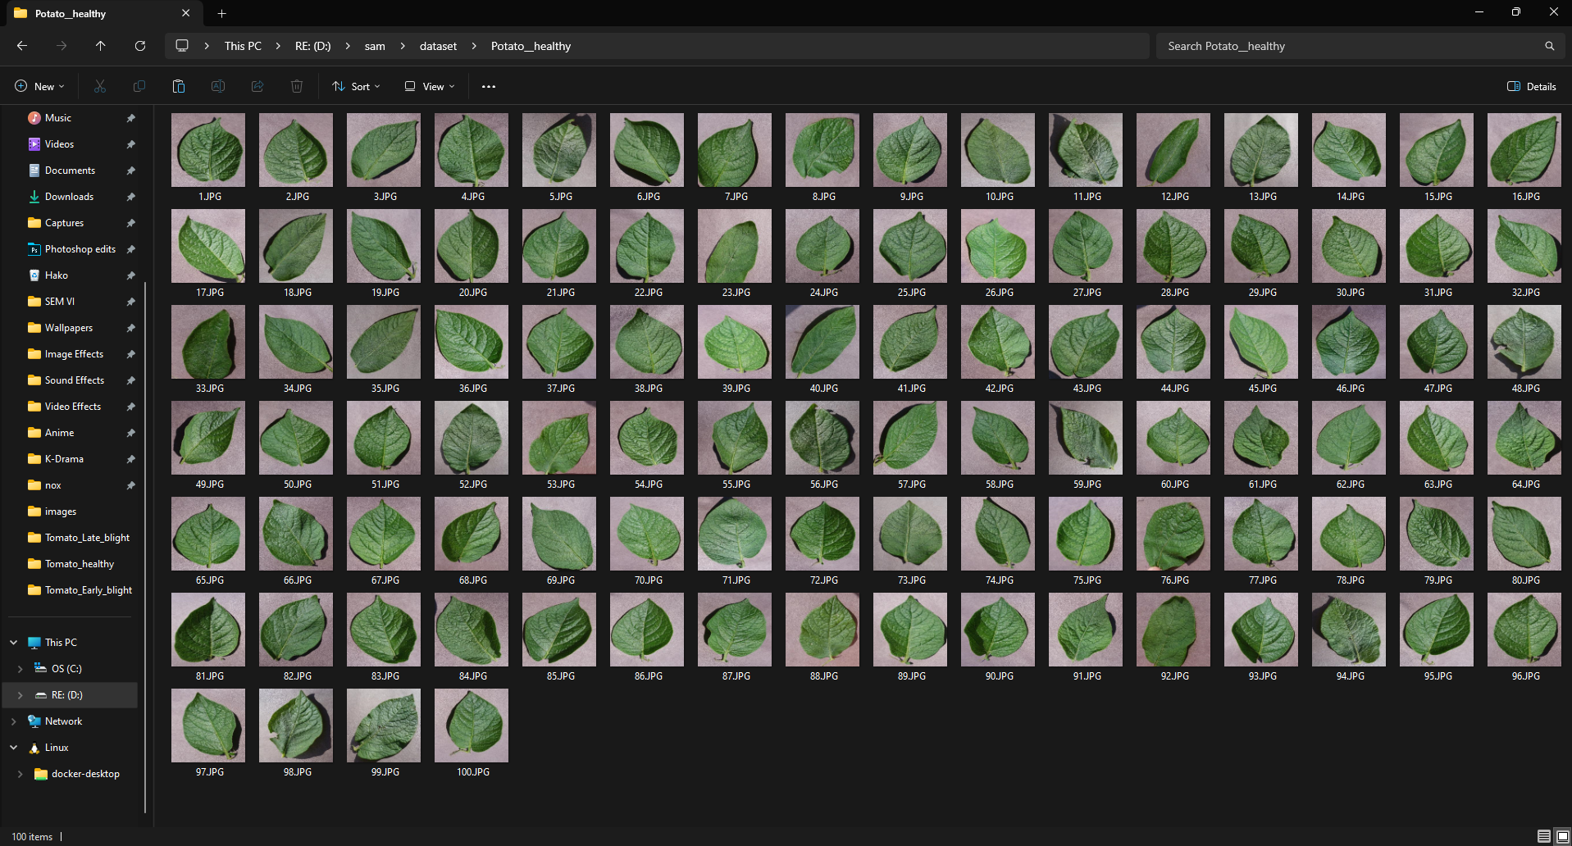
* **Class 2 (Potato Late Blight)**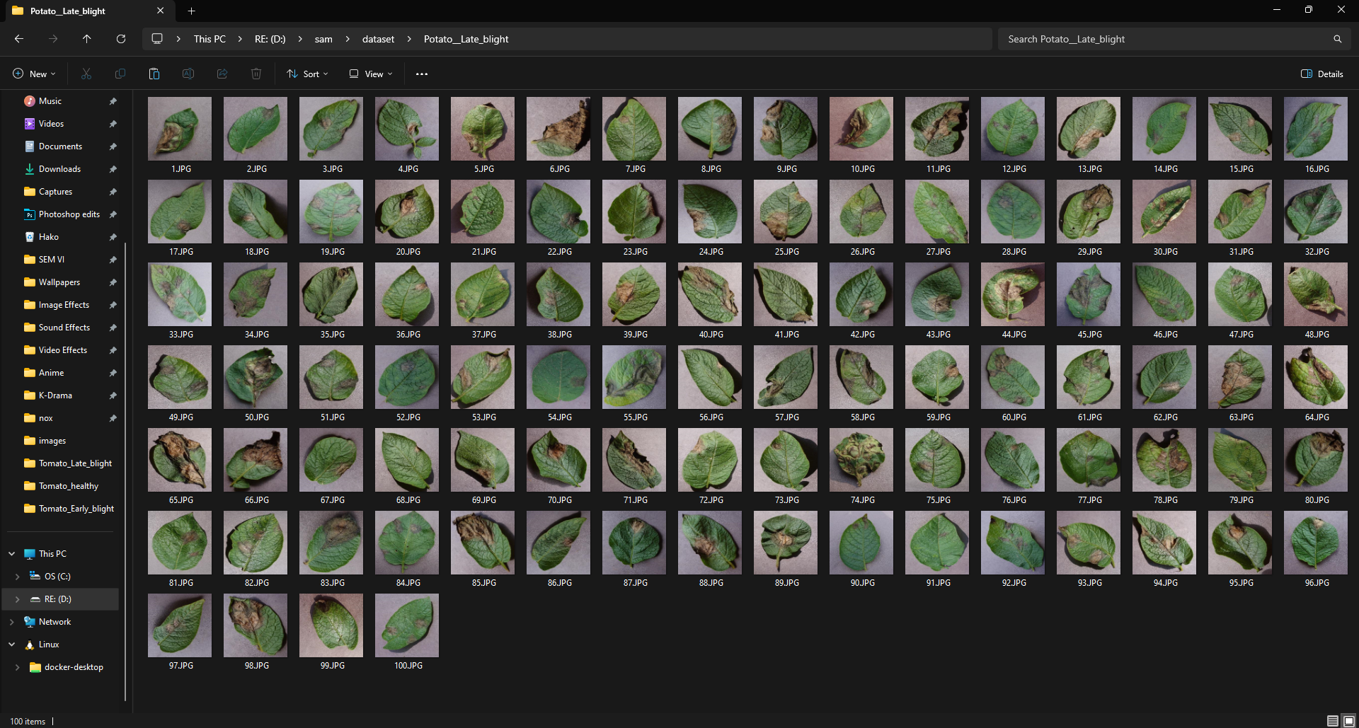

### **Model Performance**

#### Model Accuracy, Classification Report & Confusion Matrix:

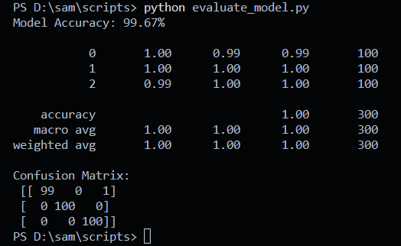

### **Model Testing**

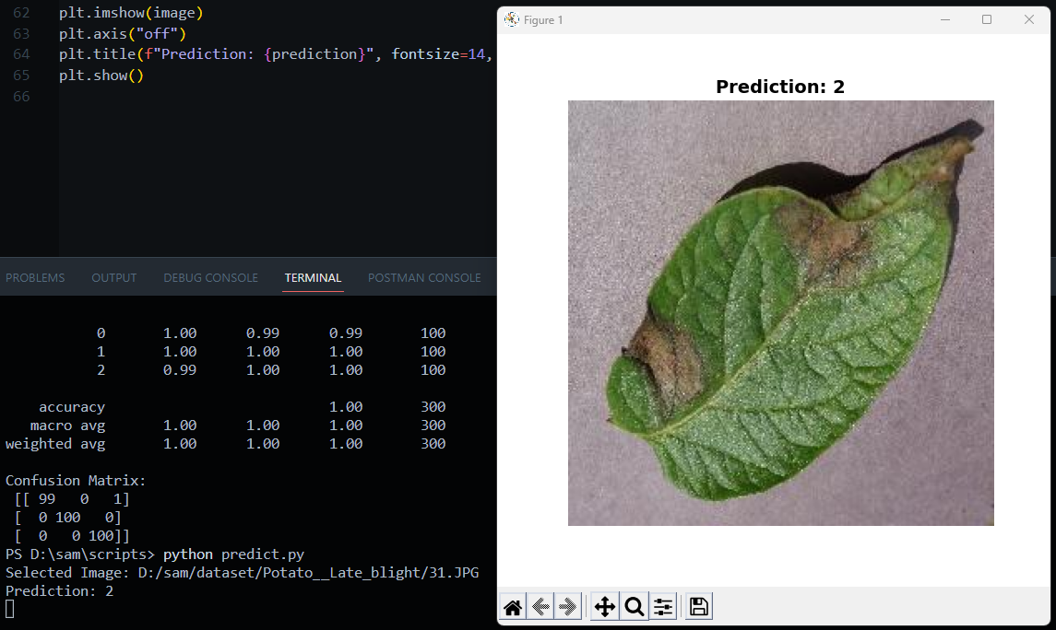

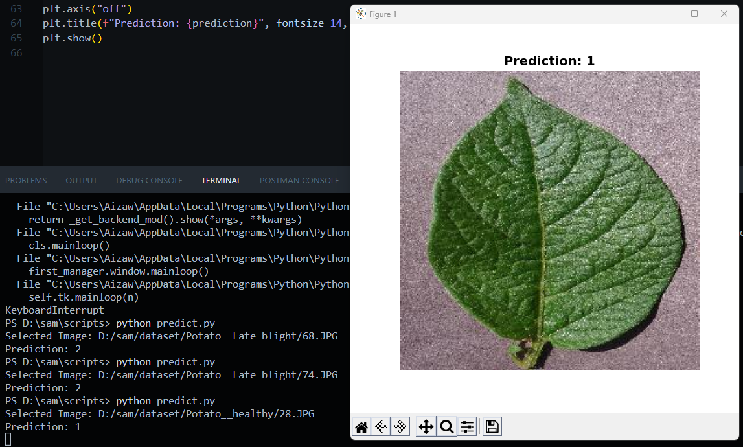

### **Notes & Observations**

* The model achieves high accuracy (99.67%) with minimal misclassifications.
* One image in Class 0 (Early Blight) was misclassified.
* Further improvements can be made with data augmentation or fine-tuning.